www.facebook.com/udallkansas
P O Box 410, Udall, KS 67146
(620)782-3512
Fax (620)782-3474
www.cityofudall.com
AUGUST 2021

City Chit Chat

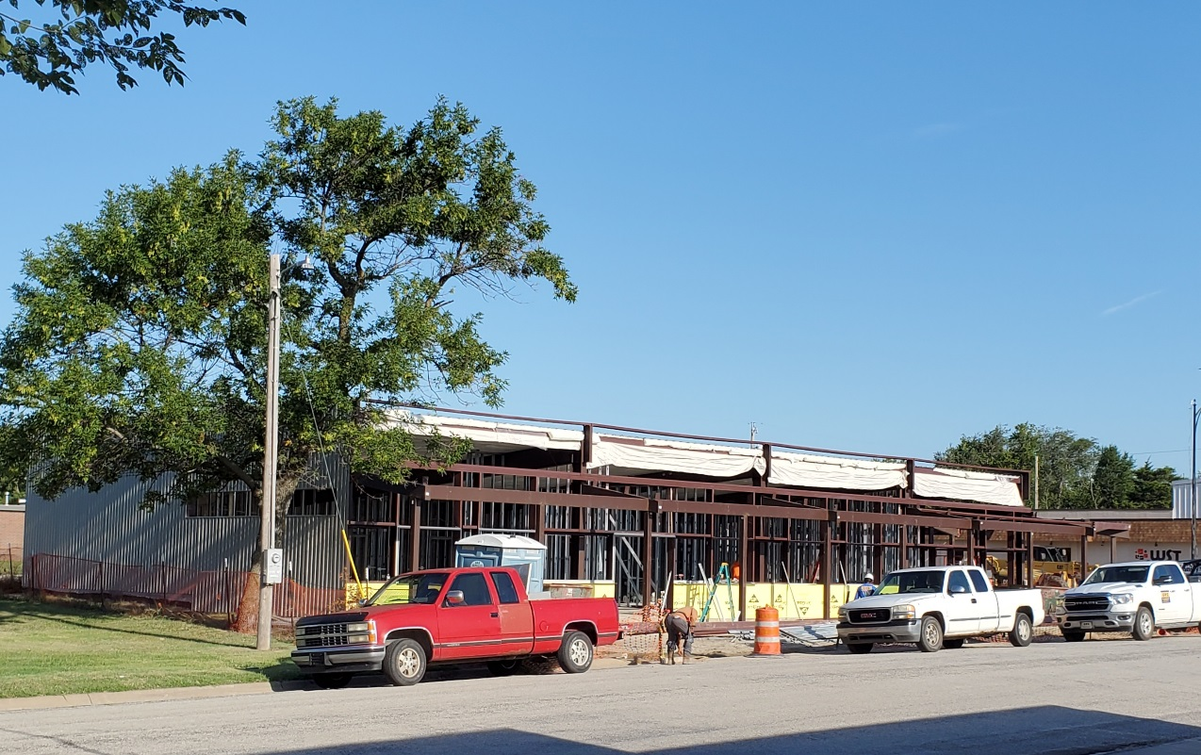

Library
&
Wellness Center

Coming along!

FALL GREETINGS! FROM THE SECOND BLESSING GARMENTS CLOTHES CLOSET!
Our September opening is Saturday, September 11th from 9:00 AM to noon. Stop by and say, “Hi,” and enjoy some cookies! We would love to have you stop by to browse and visit. New items are put out every month. We have quality clothing for the entire family. There is never any charge for any of the items. Freewill donations are accepted. We are a compassionate ministry of the Udall Church of the Nazarene. We always gladly accept donations of clean good clothing. Please NO household items or toys!! If you have any questions, want to donate clothing, or have an emergency clothing need, please call Terri Britt, Director, at (620)218-9607 or (620)782-3014. This community outreach is open on the second Saturday of each month from 9:00 AM to noon in the church annex at 2nd & Church streets. Church office – 782-3683. We are a division of the international compassionate ministry Hope Compassion Outpost – USA/Int’l.

CITY-WIDE CLEANUP
…. ….

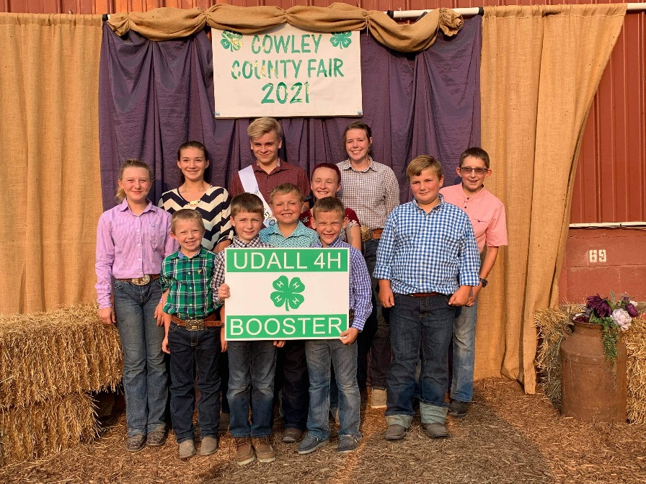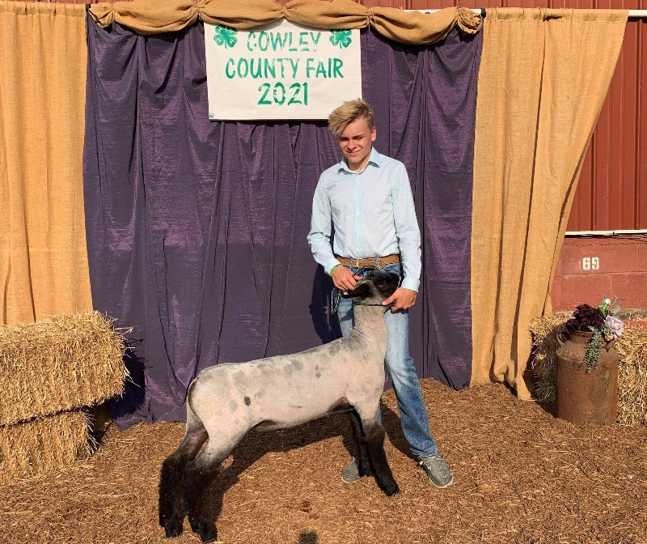
The Udall 4-H Club and the Udall 4-H Booster Club would like to personally thank the Gene Beard family and the Udall Community for supporting us through the Gene Beard Memorial. The donations allowed us to purchase Andrew Preston’s lamb at the Cowley County Premium Auction. The remaining funds will allow for 4-H Camp Scholarships for the next 10+ years. We hope to promote Gene’s love for agriculture and continue to remember a man that meant so much to our community.

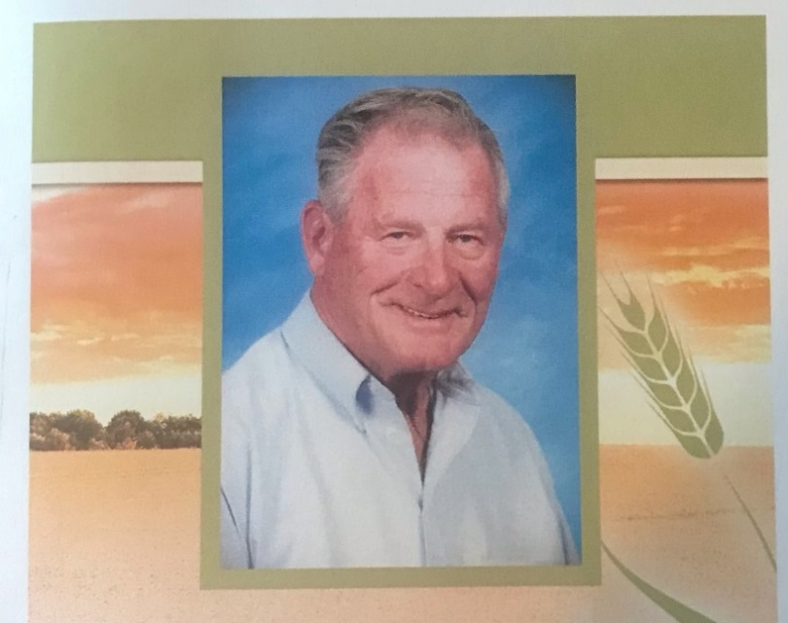
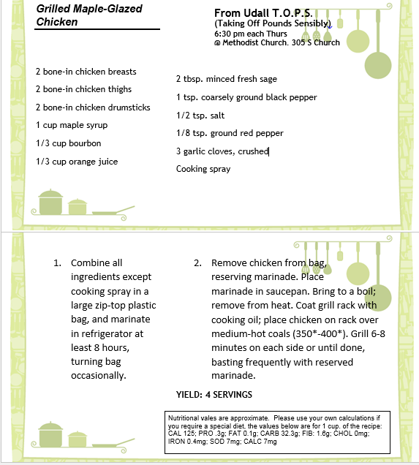
Udall Public Library is accepting applications for a part time (approx. 20 hrs. per week) Librarian/Director. Library experience is preferred. Applications can be picked up at the Udall Public Library or the Udall City Building and returned to the library or mailed to the Udall Public Library, 109 E 1st, Suite B, Udall KS 67146/ Job duties may be found on the City of Udall website or at the library. Pay will depend upon experience. Applications will be accepted until 09/30/2021.
The Cowley County Health Department will be offering flu shots at the Udall Senior Center following the afternoon potluck @ 1:00pm

REGULAR COUNCIL MEETING CITY OF UDALL Monday, July 12, 2021
The Udall City Council met for the Regular Council Meeting on Monday, July 12, 2021, at 6:30 p.m., at the Udall City Building. Stephen R. Brown, Mayor, called the meeting to order. Council members present were Janette Adams, Kenneth Ault, Matt McAllister, Brandon Lawrence and Carlton Smail. Quorum established. Also present were Erik King, Tim Brooks, Jack Kistler and Sara Barry.
MODIFICATION OF AGENDA: none
BUSINESS FROM THE FLOOR: Jack Kistler addressed council regarding drainage solutions and offered use of his land if needed for this reason at the new Library/Wellness Center site.
GENERAL DISCUSSION: none
CONSENT AGENDA:
1. MOTION: by Ault, second by Adams, to approve the consent agenda including the Regular Meeting minutes of June 14, 2021, Special Meeting minutes of June 18, 2021, and Special Meeting minutes of June 29, 2021, Expenditure Report for 6-13-2021 – 7-12-2021 in the amount of $67,080.07 and Payroll Account Report of $13,895.41. All voted aye, motion carried.
OLD BUSINESS: 1. Library/Wellness Center: a.
MOTION by McAllister, second by Lawrence to approve Change Order #05 in the amount of $6,034.00 due to changes in doors for adhering to fire code . All voted aye, motion carried. b.
MOTION by Lawrence, second by Ault to approve pay request #06 and CDBG drawdown #06. All voted aye, motion carried.
NEW BUSINESS: 1. Approve CMB license for Old Skool Productions LLC for the July 17th race.
MOTION: by McAllister, second by Smail to approve CMB license for Old Skool Productions LLC for the July 17th race. All voted aye, Motion carried.
2. Council discussed the 2022 year recycle rate increase,
NO ACTION TAKEN.
3. Council discussed the approval of future possible parking lot repairs behind new Library in the event that the City needs to access the utilities.
MOTION: by Ault, second by Lawrence to table this issue for the time being to gather more information.
COUNCIL MEMBERS REPORTS:
1. Matt McAllister asked about the condition of the demo derby track and Tim Brooks gave an update on the condition as well as some options we might have to upgrade the track
2. Kenneth Ault gave praise to the maintenance department for filling in some pot holes that needed attention in a timely manner
3. Janette Adams asked about the dirtwork update from a tree that the city removed in her yard, Tim Brooks addressed her question
4. Brandon Lawrence asked about the process for weed notices Erik King addressed this question. Lawrence also addressed the council about a citizen’s complaint to him about some blighted property
5. Carlton Smail reported that the firework show, flyover and ice cream social went very well. There was 176 servings of ice cream that were purchased and each piece got distributed to those joining the celebration
STAFF REPORTS: 1. Tim Brooks representing Maintenance for Eric Allen- a. Requests the purchase of 2 weed eaters and 1 leaf blower as it was recently discovered an employee had voluntarily been bringing their own in for City use because the City’s was inoperable. Purchase total not to exceed $1,259.97
MOTION: by Ault, second by Smail to approve the purchase of 2 weed eaters and 1 leaf blower not to exceed the total amount of $1,259.97 . All voted aye, motion carried. 2. Erik King- Reported he’s got another meeting with FEMA this week and our case has been transferred to the KC area, so we’re getting closer to being done with that reporting.

3. Sara Barry reported that we plan to exceed the new RNR (Revenue Neutral Rate) suggested by the state as many towns will also be doing. We will need to hold an additional budget hearing for that before the traditional budget hearing to meet those requirements. Also discussed the Library budget changes. The City will also be applying for non-budgeted funds from ARPA (American Rescue Plan Act of 2021)
4. Steve Brown spoke about community development options regarding the buildings downtown that are owned by the City and currently vacant. He also reported that there is interest in doubling the function of the demo derby arena as a rodeo arena as well. There will be more information on this in the future.
ADJOURN: 1.
MOTION: by Ault, second by Smail to adjourn the meeting. All voted aye, motion carried. Sara Barry, City Clerk

Udall 4-H Minutes
The August meeting of the Udall 4-H club was held on August 1, 2021. President Andrew Preston called the meeting to order. The Pledge of Allegiance was led by Landry Robinson and the 4-H Pledge was led by Lee Preston. Junior Secretary Brilee Pelligrini read the minutes of the July meeting and led roll call with the question “what is your favorite part of the fair?” Members answered with “improving from past years”, “showing animals” and participating in the “Barnyard Olympics”.
Project leaders congratulated all members on hard work during the fair.
The banner committee report was made by Andrew Preston who shared that the club banner fair entry received a blue. It’s title was “Growing Great Citizens Through 4-H” and was decorated with brightly colored felt flowers representing leadership, responsibility and communication to name a few.

Community leader Laura Jelinek recognized all member achievements during the fair asking them to stand if they received blue up to Grand Champion awards and all members were included. Leader Leslie Mikos reminded members to enter qualified projects for the state fair before the end of the fair, that a record book party will be announced at a later date and that next month we will hold officer elections.

Under old business Britney Murphy thanked all who worked in the food stand.
Under new business Laura Jelinek reminded families to pay for club T-shirts. Andrea Ahlerich let the livestock members know there are booster signs to deliver to their buyers and they will take a group photo before the sale held on August 2, 2021.
Jake Jelinek led the club in singing “Happy Birthday” to the August birthday members.

The meeting was adjourned.
Next month’s meeting has not been set at this time.

Addison Robinson
Udall 4-H Reporter

City of Udall
P O Box 410
Udall, KS 67146

Want the CHIT CHAT mailed to you?
call 782-3512,
email udallcty@cityofudall.com
or go online at cityofudall.com

SEPTEMBER 2021 2021

Sunday | Monday | Tuesday | Wednesday | Thursday | Friday | Saturday
 |  |  | 1 | 2  T.O.P.S.  6:30 PM @  Methodist Church | 3  Senior Center  Potluck @ 12pm | 4
5 | UMC: 6  TEFAP @ 1pm | 7  UMC  Food Pantry  @ 2pm | 8 | 9  T.O.P.S | 10 | 11  Community Closet 9-12 Nazarene Church
12 | 13  Council Meeting @6:30pm | 14  Udall Community Bldg Board | 15 | 16  T.O.P.S | 17  Senior Center  Potluck @ 12pm | 18  CITY-WIDE CLEANUP
19 | 20  Utility  Payments due BY 4pm  to avoid a 10% late fee | 21  UMC  Food Pantry @ 2pm | 22  Autumn begins | 23  Meter Reads  Please restrain dogs  T.O.P.S | 24  Meter Reads  Please restrain dogs | 25
26 | 27 | 28 | 29 | 30 | 1  OCTOBER | 2

